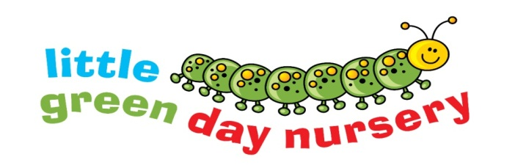
Our snack menu
at the Scout Hut
 | Snack
Monday | Crackers and cream cheese  Serve with pepper and pear slices
Tuesday | Crumpets  Served with sugar snap peas and apple slices
Wednesday | Ham or Cheese sandwiches  Served with cucumber and satsumas
Thursday | Pita bread and dip  Served with carrot sticks and banana slices

All meals and snacks are freshly prepared in our own nursery kitchen.
A choice of milk or water is offered at snack time.
Water is available to all children throughout the day.

